

Airbnb Market Trend Analysis for Washington, DC Market

**Executive Summary**

This analysis of Washington, DC's Airbnb market identifies critical drivers of revenue optimization for hosts and offers actionable insights into strategic investments. The data reveals that hosting in premium neighborhoods such as Georgetown, Dupont Circle, and Shaw leads to a price premium of $27, $21, and $13, respectively, in nightly rates. Furthermore, hosts earning the title of Superhost and maintaining an acceptance rate above 90% show elevated nightly rates of $22 and $34, respectively, indicating that host reputation plays a discernible role in driving revenue.

Furthermore, property features play a critical role in maximizing revenue. Each additional bedroom and bathroom adds approximately $43 to the nightly rate, emphasizing the demand for accommodations that can host larger groups and offer enhanced amenities. Hosts who focus on optimizing property capacity and features, alongside maintaining a high service standard, are well-positioned to achieve higher occupancy rates and profitability. These insights provide a strategic framework for hosts looking to thrive in Washington, DC's competitive short-term rental market.

The data highlights that making strategic investments in premium neighborhoods, achieving Superhost status, maintaining a high acceptance rate, and optimizing property features are crucial for maximizing Airbnb revenues in Washington, DC. Areas like Georgetown, Dupont Circle, and Shaw tend to command higher prices, reflecting their desirability. Hosts who attain Superhost status and have high acceptance rates see noticeable increases in nightly rates, emphasizing the value of a strong reputation. Additionally, properties with more bedrooms and bathrooms are in greater demand, as they can accommodate larger groups and offer enhanced amenities. Focusing on these factors, positions hosts to attract more bookings and increase profitability.

**Overview**

Washington, DC is home to many cultural attractions, historic sights, and political landmarks, all of which entice tourists and business travelers alike to visit the capital of the United States. The data shows us what we know intuitively: the price of the listing and the neighborhood area are connected. The more exclusive the area and the closer an Airbnb is to some of the most famous landmarks in the city, the higher the price will be. Washington, DC, has witnessed a critical mass in the short-term rental market, and Airbnb hosts, involved with the tourist-driven demand, are profiting from it.

In addition to the rising demand, many more public and private property owners in Washington, DC, have been buying into Airbnb and offering short-term rentals. Investors, mainly, are betting on the substantial return – especially in the more high-traffic neighborhoods. It’s easy to see why many buy or convert property solely for short stays. This reflects more significant shifts in the real estate market as some homeowners and property managers see short-term rentals as a strategy for making more money than possible through traditional, long-term leasing. The data analysis of Airbnb listings shows that situating a listing in the right neighborhood and booking the right property type can make all the difference in how rentals are priced and whether or not investors profit.

**Notable Market Trends**

1. **Neighborhood-Specific Demand**: Certain neighborhoods have substantially more Airbnb activity. In particular, neighborhoods near downtown, major tourist attractions, and government buildings have more listings and higher prices. Capitol Hill, Dupont Circle, and Georgetown are in high-demand neighborhoods with more listings and higher prices due to their proximity to major attractions and business districts.
2. **Increase in Average Nightly Rates**: As demand for short-term rentals has risen, so have Airbnb homes' average nightly rates. This is especially evident during times of heightened demand, such as major events or popular travel months, and for homes in premium neighborhoods or with desirable amenities.
3. **Shift Toward Entire Home Rentals**: While the original Airbnb offering was shared accommodations, the trend towards ‘entire home/apartment’ rentals became dominant over the later years, making such places more attractive to travelers, particularly for families or groups who prefer to have their own space and privacy (these homes/apartments are also easier to rent out than rooms in a shared place), often charging a premium for those places and remaining more fully occupied.
4. **Investment-Driven Growth**: Airbnb has attracted several real estate investors who buy properties to convert into short-term rentals. These properties are part of a growing trend in some urban neighborhoods. They could impact local real estate prices and the availability of long-term rental units.

**Methodology**

The methodology for this analysis involved a comprehensive examination of Airbnb listings and reviews in Washington, DC. Data was sourced from Inside Airbnb, merging two datasets—listings and reviews—using unique identifiers to create a holistic dataset of 1,718 observations across 16 variables. Key variables included neighborhood, room type, host behavior, and pricing. Missing values were addressed using logical imputations, such as mean values for missing host acceptance rates and inferred room types based on contextual data. Visualizations, including histograms and box plots, were used to analyze price distributions and neighborhood trends. A multiple linear regression model was applied to identify factors significantly influencing listing prices, such as Superhost status, number of bedrooms, and neighborhood while addressing multicollinearity concerns using Variance Inflation Factor (VIF) analysis. This approach provided robust insights into pricing dynamics in Washington, DC's Airbnb market.

**1. Data Exploration**

Our exploratory analysis of the Washington, DC, Airbnb dataset began with a comprehensive examination of the data structure, followed by addressing missing values and visualizing key trends. The dataset was constructed by merging two critical sources—listings and reviews—using the relevant 'id' and 'listing_id' columns. This integration provided a holistic property view, combining host information, property features, guest reviews, and pricing details. The final dataset comprised 1,718 observations across 16 variables, capturing essential attributes such as neighborhood, room type, host behavior, property characteristics, and pricing.

A crucial step in the analysis was the treatment of missing values, ensuring data integrity for accurate insights. We employed a structured approach to handle these gaps. For instance, the host_acceptance_rate variable had several missing values, imputed using the mean acceptance rate of 0.939, ensuring consistent host behavior metrics across the dataset. Similarly, missing values in the room_type column were inferred based on contextual clues, such as the number and type of bathrooms. This method allowed for a logical imputation, maintaining the accuracy of the property classification. We also addressed missing data in the bedrooms variable by leveraging related variables like beds, imputing the mean number of bedrooms for listings with multiple beds. For listings with missing bedroom data that only had one bed, we assumed it would be one bedroom as most of the one-bed listings were one bedroom.

To ensure the bathroom variable's usability, we cleaned the data by stripping non-numeric characters and converting the values into a numeric format, enabling precise analysis of bathroom-related property features. We identified missing values in the avg_rating column and imputed the missing values with the average value of the avg_rating column. After these data cleaning efforts, we re-checked for any remaining missing values, ensuring that the dataset was complete and reliable for further analysis.

With a clean dataset, we proceeded to explore key patterns through visualizations. A histogram of the price distribution revealed a right-skewed pattern, indicating a large concentration of lower-priced listings and a smaller number of high-end properties. This highlights a significant market presence for affordable short-term rentals and points to opportunities in premium segments. Additionally, bar charts illustrating the distribution of listings by neighborhood provided insights into geographic concentration. As shown in Fig 1, the Union Station area had the highest concentration, followed by Capitol Hill and Dupont Circle.

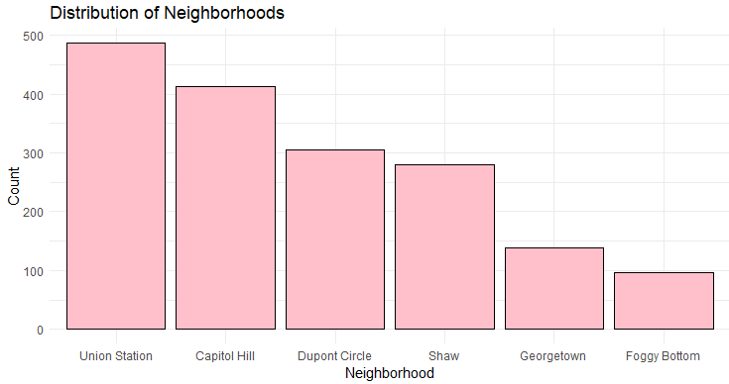

Fig 1.

Boxplots were used to compare pricing across neighborhoods and room types to investigate price dynamics further. This analysis revealed significant price variability, with premium neighborhoods like Georgetown and Dupont Circle commanding higher median prices, particularly for entire home listings. This pricing variability aligns with these areas' desirability, driven by proximity to major attractions and overall market demand.

Overall, the exploratory analysis offered critical insights into the structure and behavior of the Washington, DC Airbnb market. By rigorously addressing data quality issues and leveraging compelling visualizations, we established a solid foundation for the subsequent in-depth statistical analysis. These insights into pricing trends, neighborhood concentrations, and the impact of property features provide a valuable lens through which to interpret market dynamics and host strategies.

**2. Combination of Neighborhood and Room Type**

Analyzing neighborhood and room type combinations uncovered significant disparities in average prices across different areas and accommodation types. Foggy Bottom emerged as the most expensive neighborhood for private rooms, with an average price of $334 a night, compared to Capitol Hill, which had the lowest average for shared rooms at just $35 a night. This stark contrast highlights how location and property type are critical in shaping pricing strategies. Hosts internationally target high-demand areas like Foggy Bottom to capitalize on these premium rates. In contrast, those in lower-demand neighborhoods, such as Capitol Hill, may need to adjust their pricing to remain competitive.

Pricing variability also revealed key insights into market dynamics. Foggy Bottom’s private rooms showed the highest variability, with a standard deviation of $234, signaling a broad range of pricing for similar properties, likely driven by factors such as property amenities and guest preferences. On the other hand, Capitol Hill’s shared rooms exhibited the lowest variability, indicating a more stable and consistent pricing structure. These findings emphasize the importance of tailoring pricing strategies to both neighborhood and room type, with premium locations offering greater flexibility and earnings potential while stable markets provide more predictable, though lower, returns.

**3. Confidence Interval Summary**

By calculating a 95% confidence interval for the average price of Airbnb listings in Washington, DC, we derived a range between $199 and $210, meaning we are 95% confident that the true average price of all Airbnb listings in the city falls within this range. This finding demonstrates the robust nature of Washington, DC's short-term rental market. The city’s unique combination of cultural landmarks, government institutions, and popular attractions drives strong demand for short-term rentals. This demand ensures properties in these prime locations can command competitive prices, benefiting hosts strategically positioning their listings near key attractions. Additionally, the price stability within this range reflects a relatively consistent market, where hosts can anticipate a reliable revenue stream, especially during peak travel seasons, significant events, or conferences, further enhancing profitability. An R-function was used to generate this result, and the function included the numerical variable and the data frame in the same variable.

**4. Testing Confidence Interval**

With the computed values, the T-test statistic is 1.46, and the critical value for a 95% confidence level is 1.645. Since the T-test statistic (1.46) is lower than the critical value (1.645), we fail to reject the null hypothesis. This indicates that there is no significant evidence to conclude that the average price of all listings in the population is more than $200.This conclusion aligns with the confidence interval reported in question 3, which ranges from $199 to $210. The confidence interval includes $200, suggesting that it is plausible for the actual average price to be $200. Therefore, the hypothesis test result where we fail to reject the null hypothesis is consistent with the estimated confidence interval. The function includes the numerical variable and the data frame in the same variable.

**5. Visualize the Normality of Data** 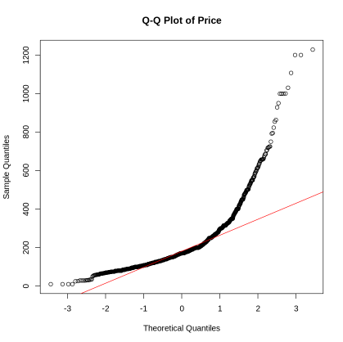

In order to explore the normality of price in the dataset, a quantile-quantile (Q-Q) plot was utilized. The points of the Q-Q plot deviate from the diagonal line, indicating that price is not normally distributed. The J-shape of the points in the Q-Q plot indicates that the price has a positively skewed distribution. Histogram and density plots also confirm a non-normal distribution for price and indicate an asymmetric positively skewed distribution vs a symmetric normal distribution. This result indicates that prices for some rentals are substantially higher than most of the rentals in the dataset, thus skewing the distribution of the price.

**6. Simple Linear Regression Model for Price**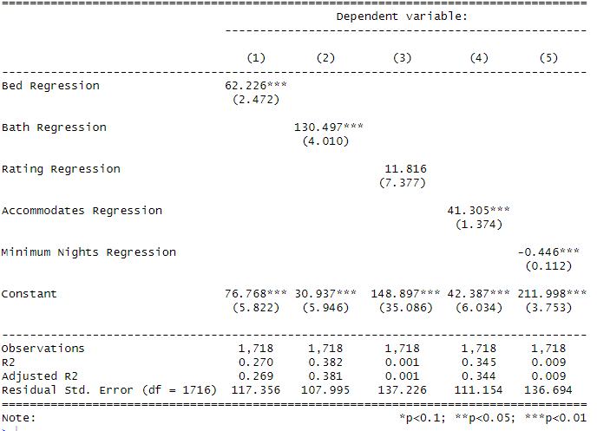

Based on the R-squared values and residual standard errors presented in the table, the best simple linear regression model for predicting the "price" of the listings is the one using "bath_n" as the predictor. This model has an R-squared value of 0.382, indicating that it explains approximately 38.2% of the variance in the "price." Additionally, it has the lowest residual standard error of 107.995, suggesting that the predictions are relatively close to the observed values compared to other models. The “bath_n” predictor is the number of bathrooms in each Airbnb property. While working with the stargazer function, we found that it could handle only five variables at a time.

Fig. 2

Table. 1

**7. Multiple Linear Regression Model for Price**

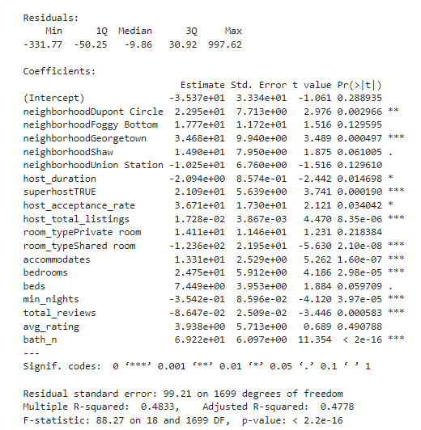When looking at the factors influencing the price of several Airbnb listings in Washington, DC, a multi-linear regression model can help identify critical predictors. The regression model shows several factors significantly affecting the price, such as bedrooms, bathrooms, Superhost status, neighborhood, and room type. These factors are influential because of their low P value (< 0.05) and their high coefficients–indicating high changes and significance in price. The R-squared value of 0.4833 means that about 48.33% of the price variation can be explained by these factors (bedrooms, bathrooms, Superhost status, neighborhood, and room type). The R-squared value suggests that these variables are essential contributors to price determination. However, other factors (property condition, seasonal fluctuations) likely also play a role. The residual standard error was 99.21, which means that even though the model provides reasonably accurate predictions, there is still some spread between the actual and predicted prices. This residual variability suggests that other unobserved factors, like property condition or seasonal demand, may also play a role in determining price.

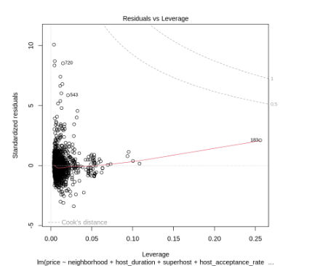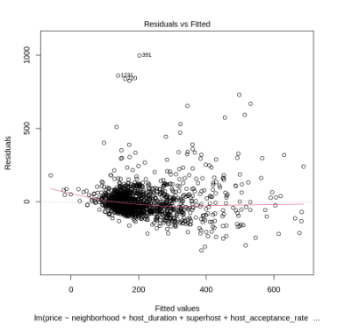

Fig 3

A residual vs leverage analysis was conducted to test normality and homoscedasticity. The results indicate that the assumptions were generally met, with minor skewness in high-end listings. This suggests that the model performs well, with small violations of model assumptions.

**8. Multicollinearity Concerns**

The Variance Inflation Factor (VIF) was calculated to address multicollinearity among the predictors. The variables, accommodation, bedrooms, beds, and host duration, showed correlations with price, indicating their potential influence on listing prices. However, the multicollinearity was within acceptable limits. In particular, the accommodations, bedrooms, and beds exhibited a stronger correlation compared to the other variable, which is understandable since properties that accommodate more guests typically have more bedrooms. Additionally, there was a slightly stronger correlation between beds and bedrooms, but overall, it fell within the acceptable limit with VIFs below five. All variables in the model had a VIF under five and fell within the acceptable range

**Conclusion**

The Washington, DC, Airbnb market highlights the critical importance of strategic investments, host reputation, and property optimization in maximizing profitability. Neighborhoods like Georgetown and Dupont Circle are ideal for investors seeking higher returns, as properties here command substantial premiums. Hosts should prioritize achieving and maintaining Superhost status, which increases nightly rates by about $22, and focus on optimizing property features—such as adding bedrooms and bathrooms, which can add around $43 per additional amenity. A high acceptance rate also plays a significant role in driving revenue, as guests value reliability. To remain competitive, hosts should continuously improve guest experiences, invest in properties with higher accommodation capacities, and ensure listings are meticulously maintained. Staying informed about regulatory changes and adjusting pricing strategies during high-demand seasons can further enhance profitability. By focusing on these factors, hosts and investors can achieve sustained success in Washington's Airbnb market.